
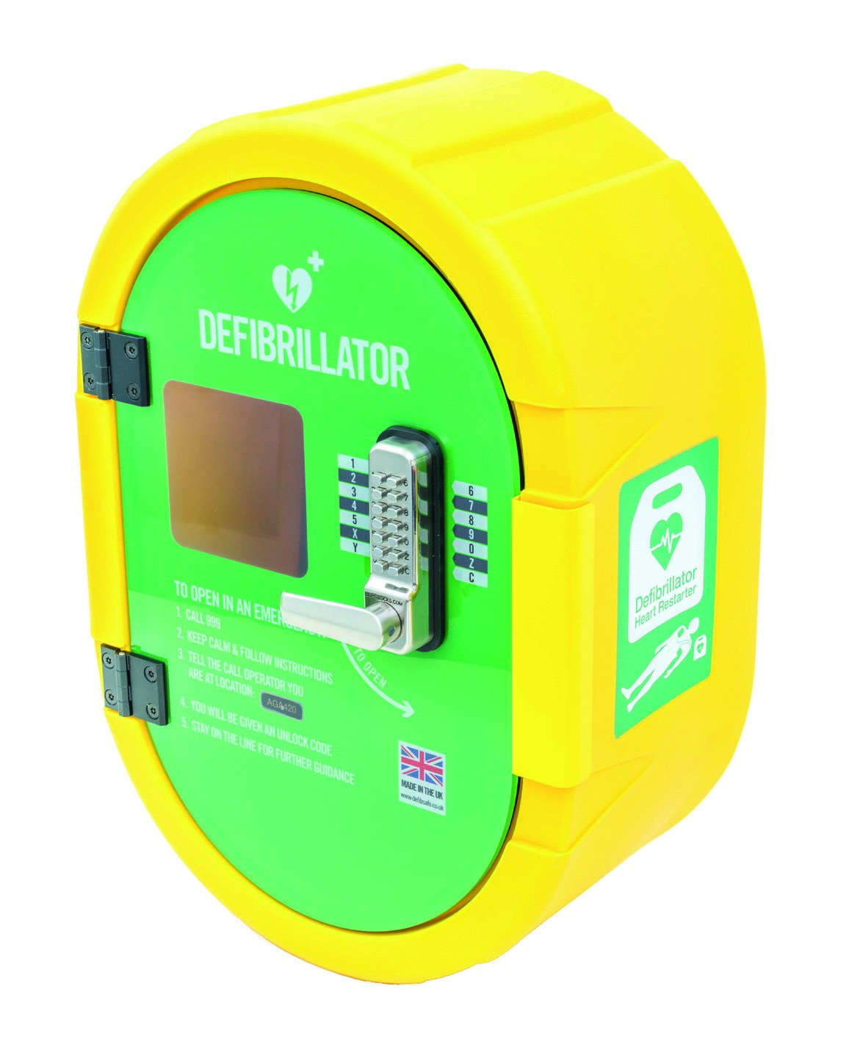
UNLOCK CODE

Cabinet
Installation
&

Usage Instructions

Installation Components
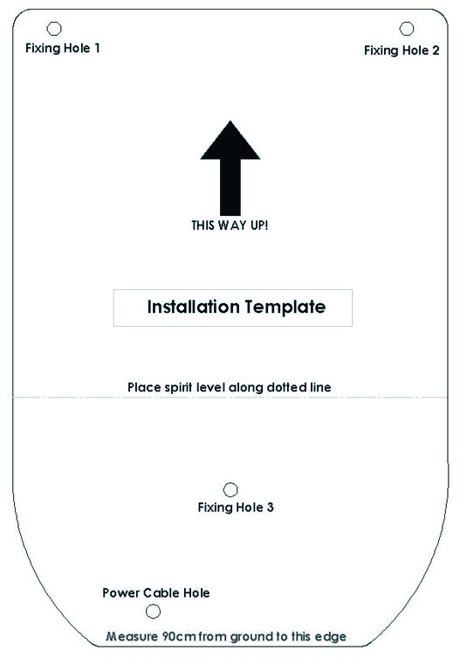

1 x Installation Template
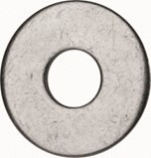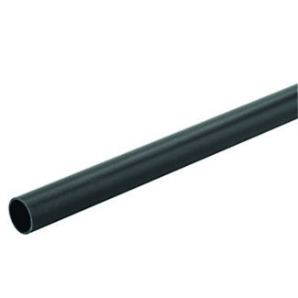

3 x Washers 1 x PVC Conduit Pipe
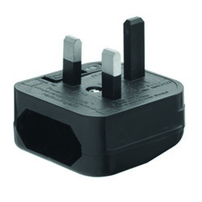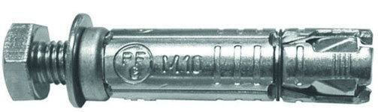
1 x UK Plug | 3 x Expansion Bolts

Required Tools
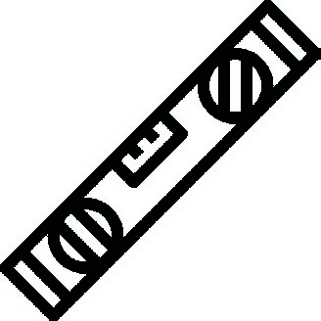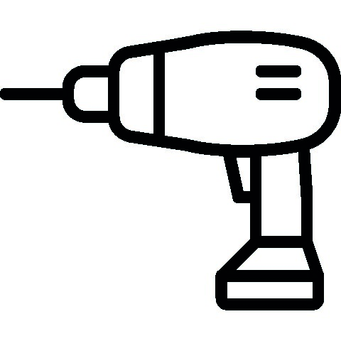
Spanner Spirit Level Masonry Drill
17 mm Spanner or 16MM Drill bit for
17mm Socket and 'fixing' holes.
Driver 20mm drill bit for
power cable hole.

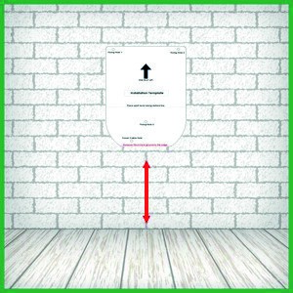
Step 1
90
cm

For best results, always install onto a flat surface. Use the installation template to mark the position of the fixing holes and power cable hole.
Check that the template is level and measures 90cm from the ground to the bottom edge of the template.

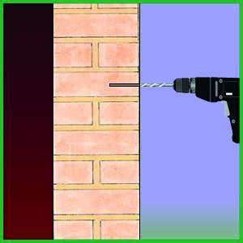
Step 2
Drill out Fixing Holes, using a 16mm drill bit, to a depth of 105mm. Use fixings appropriate for your installation.

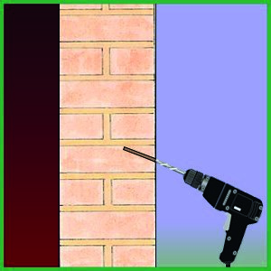
Step 3
If required, drill out the Power Cable Hole. Use a 20mm drill bit and drill through the wall at slight angle to prevent water ingress.
When drilling into soft material, consider using resin to secure bolts.

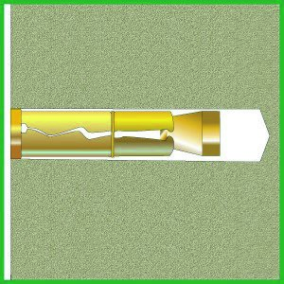
Step 4
Insert the Expansion Bolts into the Fixing Holes and tighten to secure the anchor. Now
unscrew the bolts.


Step 5
PVC Conduit Tube

Power Cable

Insert the Conduit into the Power Cable Hole. Trim to required length.
Feed the Power Cable through the Conduit and simultaneously offer-up the cabinet to the Fixing Holes. Use of an assistant is recommended.

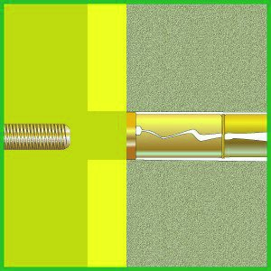
Step 6
Making sure the cabinet is flush against the wall , insert the 3 Fixing Bolts from inside the cabinet. Use washer as shown. Now tighten
the bolts. Do not over-tighten as this may distort the cabinet. Washer

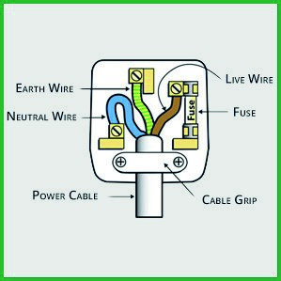
Step 7a
Now you are ready to connect the power. A competent person should wire-up the plug.
Label the plug: “EMERGENGY POWER SOURCE— DO NOT DISCONNECT”. This is to ensure no one accidentally turns off power to the cabinet.
 | 
 | DO NOT ATTEMPT TO HARD WIRE IN THE DEFIBSAFE 2 UNLESS YOU ARE A QUALIFIED ELECTRICIAN. DOING SO COULD RESULT IN HARM TO YOURSELF OR OTHERS.

Step 7b
It is possible to hard wire the DefibSafe cabinet to the mains electricity supply. This should be completed by an electrician.
Always ensure that a Residual Current Device (RCD Unit) is present when connecting the cabinet to main's electricity. 240V AC Enters this cabinet.
Ensure the Cabinet electrical supply is protected by an RCD and a 3A Fuse.
An isolation switch is highly recommended.

USAGE
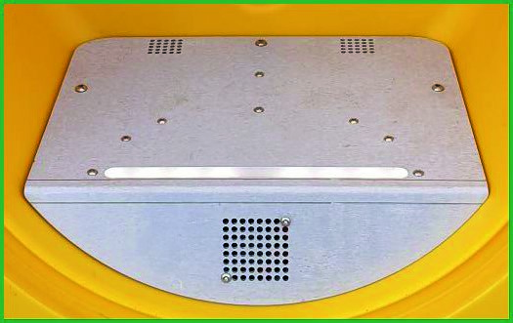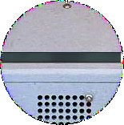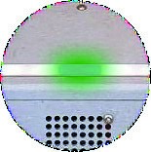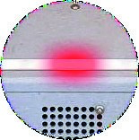
Temperature Control
-
LED STATUS

FLASHING GREEN LIGHT

The circuit is
functioning normally

Notes:
The heater will only turn on when the internal temperature
is
cold enough to
activate the heaters. The cabinet is designed to maintain an internal temperature
above 5
°
C

The metal floor of the cabinet is heated from below. When the heaters are on, a fan
is activated to circulate warm air. An override sensor prevents the floor
from
overheating..
FLASHING RED LIGHT

Reason:
The DefibSafe2
’
s internal temperature is
registering below zero
or

a
temperature sensor is faulty.

Notes:
Remove the defibrillator until temperature is above 5
°
C. If
the
problem
persists contact WEL Medical Limited.

NO LIGHTS

Reason:
A power cable has been disconnected
or
the circuit has developed a fault.

Notes:
Check
all

electrical connections.

Care and Maintenance

Weekly
• A visual check to ensure the Status Light is green and an operational check to ensure the lock is functioning correctly: Push each button followed by 'C' (clear), followed by a test of the code.

Monthly
- Wipe the surface of the lock with a dry cloth to remove any surface moisture. If there is a build-up of dirt use GT 85 spray or similar to remove this
- Clean the outside and inside of the cabinet using a hard surface cleaner

Annually
• Using GT 85 or similar, spray the lock latch and keypad, especially around the buttons and knob of handle. Push each button followed by ‘C’ (clear) 2 or 3 times and 1 final test of the code to ensure it is working correctly.

Troubleshooting

DOOR WILL NOT CLOSE EASILY
Possible reason: The door requires a firm closing action in order to achieve a watertight seal. As the gasket compresses over time, the closing action will require less force.
Solution: Do not slam the door, instead press directly and firmly on the handle until you hear the latch click into place. Ensure the cabinet door is shut.

HEATER NOT WORKING
Possible reason: There might be a fault in the circuit or no mains power.
Solution: Check the colour of the flashing Status Light and electrical connections.

THE KEYPAD LOCK IS STICKING
Possible reason: There may be a build up of dirt in the lock mechanism.
Solution: Carry out the lock maintenance steps described under ‘Annually’ above.

The DefibSafe 2 Cabinet is manufactured in the UK by WEL Medical Ltd Tel: 01252 344007 For Warranty Terms and Conditions, please see www.defibsafe.co.uk

